Orynbayev Amantay, Rzabekov Nursultan, Bekes Azamat

Assem Talasbek

Database Management Systems 2

December 1, 2019

**An application that helps you choose your favorite profession**

To paraphrase Confucius: if you make a hobby your profession, then you will not have to work a single day in your life. True, then you will not have a hobby either. But there will be a matter to which it is not a pity to devote all your strength and time. This, of course, is an ideal situation. But in any case, the profession must be chosen so that then it will not be excruciatingly painful, sad and boring. How to choose a business that will be to your liking?

**Introduction**

As mentioned earlier, we want to provide a platform where everyone can find their favorite profession for themselves. Before you will be the application (UI / UX), at the beginning of which you can choose objects that you like. Next up are questions that will narrow your search. The questions will be on the example of “What do you like of this?” And most interesting, the questions will change, looking at your previous answers. After you answer all the questions, you will be given about 30 professions. Now the fun begins, before you open a map of Kazakhstan, and there you will see universities where you can study for this profession. Choosing a University, our database will provide you with professions for this university. You see, everything is simple and clear. Well, most importantly, we helped you find your favorite profession.

Any choice of profession can be considered as the interaction of two parties: a person and a profession. A person is characterized by some individual characteristics that are manifested: in his physical development, in opportunities, interests, inclinations, character, temperament. Adapting to these features, we want to help you choose YOUR profession.

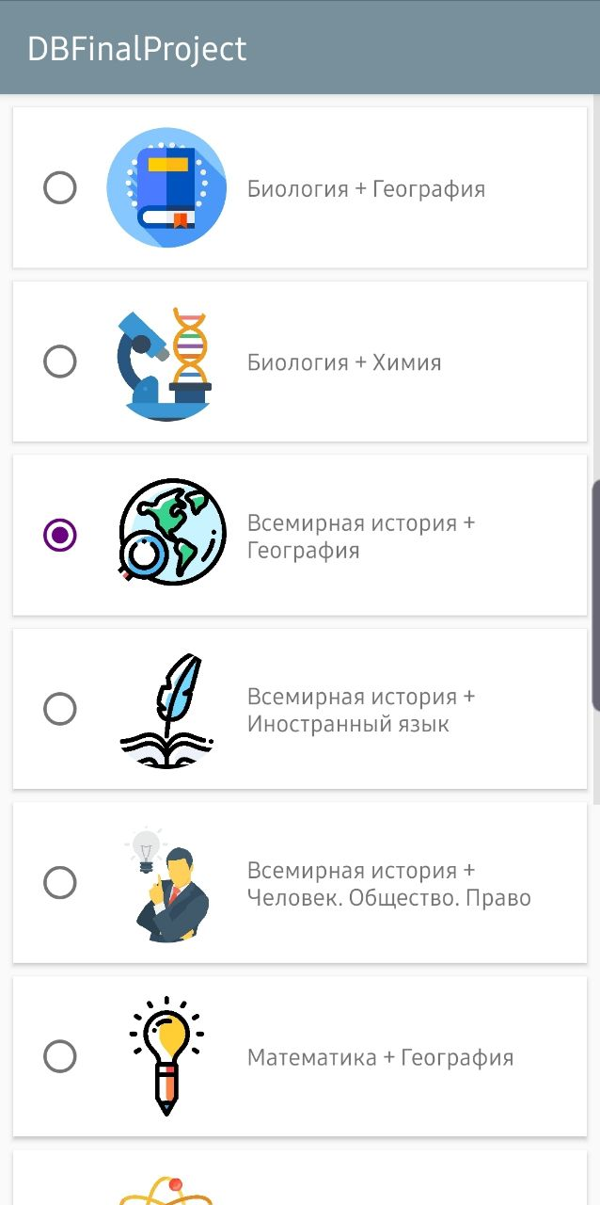

This is what the first page looks like. Here is a selection of subjects and questions. What's going on here? The application sends a request for Back-end. The Back-end immediately processes this request and contacts Oracle database. In DB, we are waiting for a function that, according to the entered data, returns a list of professions. Let's talk a litt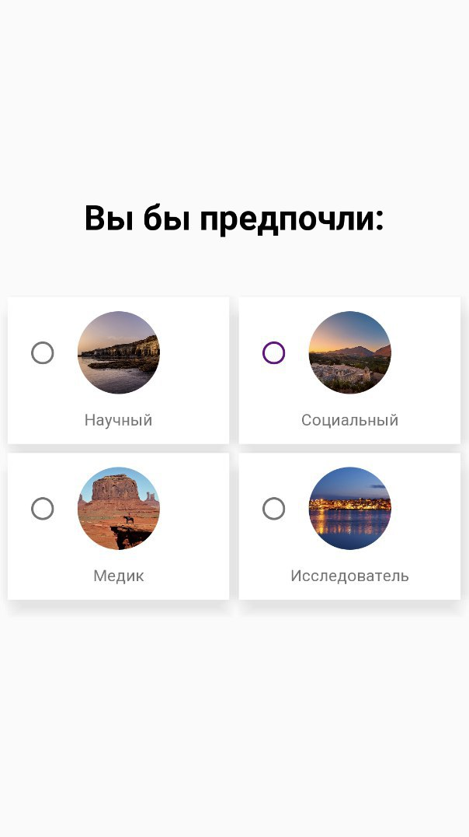le about this function. To it, how the arguments come from the items that we have chosen, and the answers to the questions. I’m not going to explain exactly how he chooses the necessary professions, but I hope you played the game Akinator (if not, then try to understand me better). That's all, in the end we create the Response which we need, and send it to the Front-end.

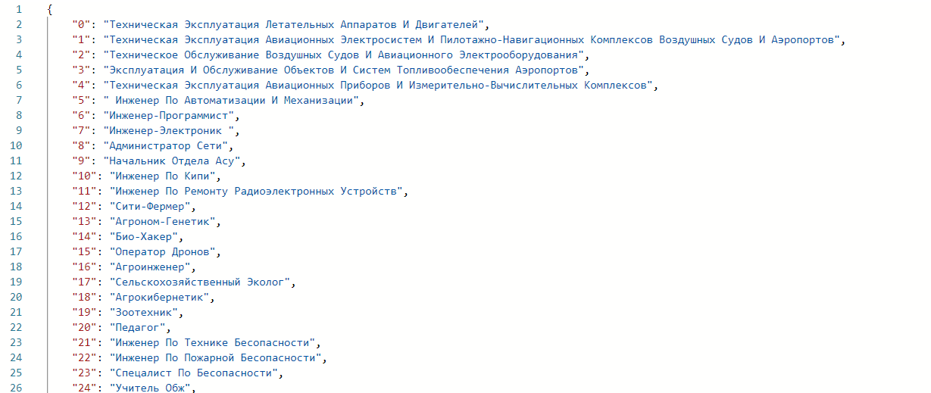

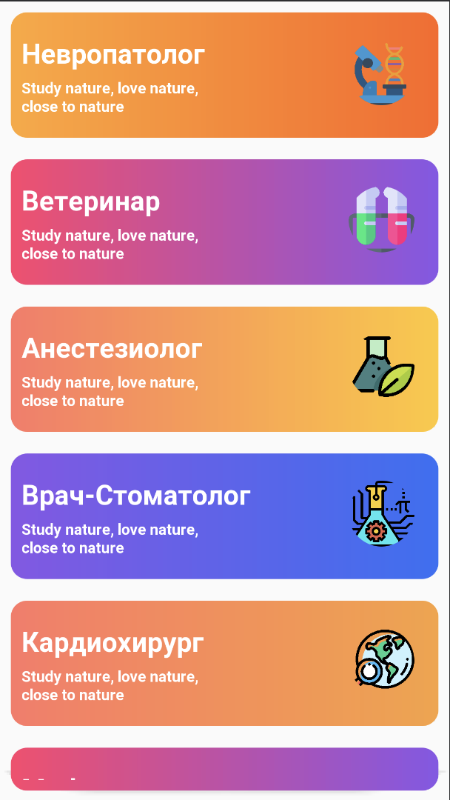

And here you see how the front-end developer made a beautiful UI/UX using the accepted Response. After choosing a profession, again back-end, again Oracle database and another function. What does this function provide? We send only the selected profession to it, and after processing, it returns a JSON file in this format:

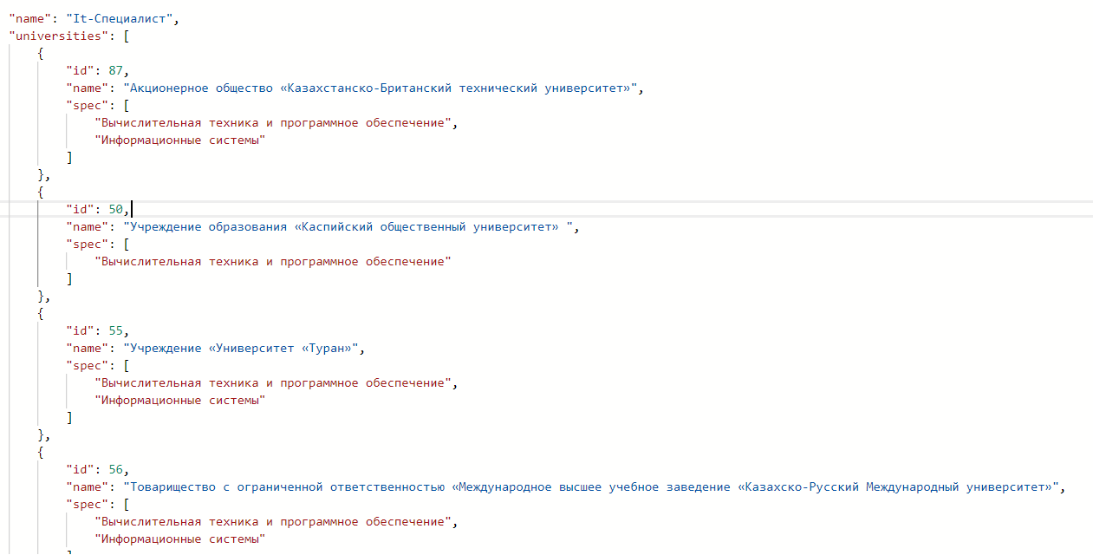

This Response is from the back-end of the developer. And so the front-end developer transformed it: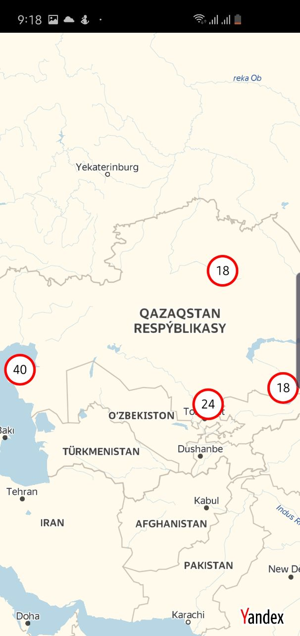

Cool, huh? This card works like this: at the beginning you see a full map of Kazakhstan, and the red circles in it are the number of universities in a certain area. If you bring it closer, the circles will be divided according to the area, and in the end you will individually see each university on the map. And if you choose the university you need, you will see the whole list of specialties at this university. Of course, you will have different input fields in order to further reduce your search. For example, you can choose universities that have dormitories or not. I still like everything!

Front-end is ended. Maybe a couple more fronts. Let's take a deeper look at the back-end. It is written in Laravel Api, which is associated with Oracle database. We have 3 triggers, 2 functions and 2 procedures.

Triggers

1) Looks at how many times certain items were selected and writes each request to a new database (subjectStatistics), where we count how many times each combination of items was selected

2) Trigger for tracking the Subject tag (insert, Update, Delete). Something like query history.

3) The third trigger, like the first, but unlike him, works with the table of the Profession. New base called ProfessionStatistics

Functions:

1) After each 1st trigger, subjectStatistics data will be changed

2) After every 3rd trigger, the ProfessionStatistics data will be changed

Functions

1) Returns professions for Intputs (subject1, subject2)

2) Returns Universities and specialties for Intput (profession)

I think that's all. I tried to make this project as simple and fun as possible. The entire front and back was fully explained. In conclusion, I want to say that this project could also help me, but I have already graduated from high school. So this project is dedicated to all schoolchildren, I hope they find themselves in this life. In the end, I would like to add the truth. A man should not be mistaken in 2 things: When he chooses a soul mate and when he chooses a profession. We helped you solve one problem, now only one is left for you. Good luck in everything and I wish to find your favorite profession.